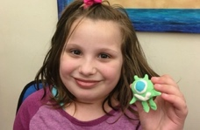

~Castlewood members, Douglas & Nicole Murray warmly extend an invitation~

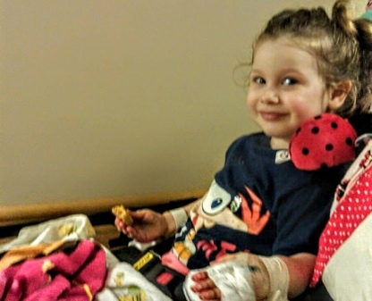
It’s A Charity Golf Tournament
benefiting our family via “Happy Sun Heart Foundation”
(Mixed - Open to Public; Men and Women)
Monday, August 27, 2018
Castlewood Country Club – The Hill Course

707 Country Club Circle, Pleasanton, CA 94566

7:30 am to 9:00 am – Registration, Warm-Up & breakfast

9:00 am – Shotgun Start (Scramble format)
2:00 pm – Heavy appetizers, awards, raffle, etc.
$175 tournament fee (per golfer) includes:

Breakfast & Lunch

18 holes, Green fee, golf cart & range access

Tee Prize, on course competitions, beverages & more

Chance to win a car for a Hole In One!

Raffle & Silent Auction to include a special “Sports Memorabilia” auction

Awards & much more…

You are invited to organize a foursome for a spectacular day on the most luxurious golf course in the East Bay. Be sure to bring extra cash & checks for mulligan packages, raffle, silent auction, honey pot & other planned fund raising activities. We look forward to hosting you for this very special event and thank you in advance for your generosity. We are humbly in need of sponsors & donations.
Club Dress Code: Tucked, collared shirts for men, standard golf attire for women; No tank tops, No Denim, and footwear is required please.

Please register, sponsor or donate before August 13th by contacting:
Nicole Murray, nicolemurraygri@yahoo.com; 925-297-9206.

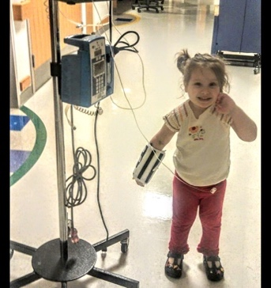

My Story ~ “Hello, my name is Emily Schiavone and I am 9 years old and live with my little brother Saverio, my mom and dad and canine fur baby, Xena.
At the age of 2 years old I was diagnosed with Gaucher’s Disease Type 3. This is a slowly progressing disease that is caused by a defective gene that prevents my body from producing sufficient amounts of an important enzyme. This disease has decreased my life span significantly. My daily symptoms include: seizures, skeletal irregularities, eye movement disorders, cognitive problems, mental deterioration, poor coordination, enlarged liver and spleen, respiratory problems, and blood disorders. I receive weekly in home infusions of an enzyme replacement; which does not cross the “blood-brain” barrier meaning that it has no effect on the severe brain involvement I suffer from.
In 2016, another rare genetic disorder was found called: Multiple endocrine neoplasia type 2 (MEN2A). MEN2A is a rare hereditary cancer syndrome, affecting approximately 1 in 35,000 people. It is associated with a 98% development rate of medullary cancer of the thyroid. This will require a thyroidectomy once the cancer levels rise. Last year, I started another treatment (IgG weekly in home sub-Q infusions) which aids in boosting my compromised immune system preventing typical illnesses that I cannot afford to go through. In 2017 & most recently, I was diagnosed with two other rare conditions; Mast Cell Activation Syndrome & Amplified Musculoskeletal Pain Syndrome (AMPS).
I am the only child globally who endures these four unrelated diseases. I have 16 teams of doctors at The Children’s Hospital of Philadelphia, and doctors in Fairfax Virginia to manage these rare diseases.
My healthcare has taken a tremendous toll on my family. Medical expenses are extreme and include copays for all the teams of doctors, extensive medication co pay upkeep, therapies, physical and mental support, pain management, and automobile fuel costs to and from Philadelphia, which varies from 3-6 x a month.
I am now using the support of a wheelchair which now requires my parents to get a vehicle that can support my transportation. My parents’ expenses exceed $2,000/month and they do not meet the criteria for state help.
On top of my personal needs, my younger brother, Saverio is 6 years old and suffers from Autism Spectrum Disorder (ASD). His behavior is quite extreme and the medications must be altered to accommodate his progression and growth. He too endures many hours of therapy.
My parents set up a Go Fund Me campaign a few years ago to help them with the medical costs and many wonderful people have helped us to date. Sadly, we are still in need of help and due to the extensive medical care, my dream home is in foreclosure.
I want to thank you for taking the time to read my story. My Aunt and Uncle; Nicole and Doug Murray have organized a charity golf event to benefit my foundation, “Happy Sun Heart” that is scheduled for August 27th, 2018 at Castlewood Country Club in Pleasanton, California. My condition prevents me from attending in person, but I do hope to be able to Skype or Facetime at the event.
Your participation, sponsorship and donations to the event would be appreciated beyond words. My Aunt and Uncle are looking for help through various sponsorships, raffle/silent auction donations & more.
If you can help in any way, or know someone or a business that can, please contact my Aunt Nikki via: nicolemurraygri@yahoo.com. Thank you so very much for your support.”
You can read more of my journey on my Caring Bridge site: www.caringbridge.org/visit/happysunheart/mystory
Mom also created a Facebook page: https://www.facebook.com/Happysunheart/
Golf Tournament benefiting Happy Sun Heart Foundation
Monday, August 27, 2018 - Castlewood Country Club – Hill Course
Sponsorship Form (Please check your selection to the left)
_____ *$3,000 Platinum Sponsor - Foursome; Company Name at Registration, your supplied banner hung outside the pro shop, sign and honored in the program.

_____ *$1,500 Gold Sponsor - Foursome; Company/Individual Name at registration, sign and honored in
the program

_____ *$800 Sponsored Foursome - Foursome; Company/Individual name on a sign and honored in the
program
_____ $500 Beverage Sponsor - Company/Individual sign at Beverage stations and honored in the program
_____ $150 Hole Sponsorships – Tee sign at a hole with your business or personal information and honored in
the event program. (Minimum of 18 needed)
_____ $200 Competition Hole Sponsorships - *SOLD FOUR, but we can always double up!*
A sign will be placed in the tee box at each hole with your business or persona information and honored in
the event program. (Four)

_____ Miscellaneous Cash Donation - You / your business will be honored in the event program along with
signage in the dining venues. I wish to donate: $_______________
_____ Food serving station on course & dessert donation by your establishment - (Two food/snack stations
are desired and one dessert donor.) A sign will be placed on the course for food service. Your business
will be honored in the event program. What will you be serving? _______________________________

_____ Award donations for winning golfers – 16 Prizes for 1st, 2nd, 3rd flights and 4 competition holes. You
will be honored in the event program.
_____ Raffle and Silent Auction items to be raffled after the round. Gift cards, gift baskets, specialty items
are all welcome.
Information for Signage
Name/Title/Info to be printed on sign: _________________________________________________________________
_________________________________________________________________________________________________
_________________________________________________________________________________________________
Contact Person: _______________________ Tel: _____________________ E-mail: _______________________
Mailing address: ___________________________________________________________________________________
Total $: ________________ (Please make check payable to Nicole Murray and notate in Memo “HSHF”)
*For sponsorships that include a foursome, please also complete golfer registration form.
Please send any logo’s or photos to: Nicole Murray – nicolemurraygri@yahoo.com Please mail sponsorship & golfer registration forms & checks payable to: Nicole Murray, c/o CWCC; 707 Country Club Cir, Pleasanton, CA 94566
(Paypal, Venmo, Square Cash are also options for payment. E-mail me for details.)
Please call Nicole with any questions @ 925-297-9206. *Please note that the foundation is NOT a 501(c).
Thank you for your support and generosity.
Golf Tournament benefiting Happy Sun Heart Foundation @ Castlewood Country Club
Golfer Registration

Player #1 Name: __________________________________________________________________________________
Mailing address: ___________________________________________________________________________________
GHIN # (or Handicap Index): _______________ Telephone #: _______________ E-mail: __________________
Player #2 Name: ___________________________________________________________________________________
Mailing address: ___________________________________________________________________________________
GHIN # (or Handicap Index): _______________ Telephone #: _______________ E-mail: __________________
Player #3 Name: ___________________________________________________________________________________
Mailing address: ___________________________________________________________________________________
GHIN # (or Handicap Index): _______________ Telephone #: _______________ E-mail: __________________
Player #4 Name: ___________________________________________________________________________________
Mailing address: ___________________________________________________________________________________
GHIN # (or Handicap Index): _______________ Telephone #: _______________ E-mail: __________________

Payment Information
Tournament Players: $ 175 X __________ = __________
Please complete this form and send along with your check payable to: Nicole Murray by August 13th via:
E-mail: nicolemurraygri@yahoo.com OR
USPS: Nicole Murray, c/o CWCC; 707 Country Club Cir, Pleasanton, CA 94566
Nicole contact tel #: 925-297-9206
(PayPal, Venmo, Square Cash are also options for payment, email Nicole for details.)

Please note any special needs such as handicap flags, dietary restrictions, etc.
__________________________________________________________________________________________________________________________________________________________________________________________________________________________________________________________________________________________________________________________________________________________________________________________________________________________________________________________________________________________________________

We look forward to seeing you on August 27th and thank you again for your participation and generosity!

